

WHITEPAPER

**CryptoAssetBox**

**The ﬁrst multichain-based marketplace**

**for the issuance of crypto assets for business**

**Table of contents**

1. What is CryptoAssetBox? 4

2. What are crypto assets? 5

3. Purpose of the CryptoAssetBox platform 6

4. Problems that CryptoAssetBox addresses 7

4.1. Start-ups struggle to access capital and technical expertise to launch their businesses 7

4.1.1 The problem: 7

4.1.2 The *CryptoAssetBox* solution: 7

4.2. Start-ups have corporate governance issues that discourage investment 8

4.2.1 The problem: 8

4.2.2 The *CryptoAssetBox* solution: 8

4.3. Traditional securities markets are illiquid and limit participation 9

4.3.1 The problem: 9

4.3.2 The *CryptoAssetBox* solution: 9

4.3.3 Benefits of security tokens 10

4.4. New tokens struggle to be listed on exchanges, and liquidity is compromised 11

4.4.1 The problem: 11

4.4.2 The *CryptoAssetBox* solution: 11

5. The product 12

5.1. Blockchain-driven ecosystem for businesses 12

5.1.1 Beneﬁts of a multi-chain platform 12

5.1.2 Features of each chain 13

5.2. Business Dapps 14

5.2.1 Token Creator 14

5.2.2 ICO Campaign Creator 14

5.2.3 Security Token Creator 14

5.2.4 Exchange Token Creator 14

5.2.5 DAO Company Creator* 14

5.2.6 Token Airdrop Creator 14

5.3. Management tools 15

5.3.1 Dashboard 15

5.3.2 Compliance and regulatory support 15

5.4. Crypto Exchange 15

6. The Risks 17

7. The Market 18

7.1. The cryptocurrency market 18

7.2. The digital assets market 19

8. Competitor analysis 20

9. Business plan 22

9.1. Income streams and projected earnings from Dapps 22

9.2. Income streams and projected earnings from Crypto Exchange 25

10. Roadmap 27

11. Reasons to invest in CryptoAssetBox 28

# What is CryptoAssetBox?

*CryptoAssetBox* is the ﬁrst multichain-based marketplace for the issuance of crypto assets for business.

It is an easy-to-use platform that will provide Dapps on 3 different blockchains, Ethereum, EOS and NEO. The focus of the Dapps will be on enabling the issuance of business-related crypto assets such as security tokens, ERC20 utility tokens and ICO campaigns. Companies will pay a fee or commission to launch their crypto assets on the platform.

It will help businesses to

* Raise crypto capital via ICOs
* Issue and manage security assets
* Tokenize and manage real-world assets
* Create various crypto assets, and
* Deploy them to the blockchain network
* Manage them easily on the dashboard
* Send proof of ownership to new shareholders via Ethereum addresses
* Manage their company as a DAO, for transparency and efﬁciency

# What are crypto assets?

Crypto assets are assets in digital form. They power most applications of blockchain technology, using peer to peer networking and a public ledger to execute and secure transactions.

All of the following types of crypto assets will potentially be launched from the CryptoAssetBox platform.

**Types of crypto assets**

**Cryptocurrencies:**

An alternative to ﬁat currencies. They act as a means of exchange, a store of value, a unit of account. Bitcoin is the most well-known.

**Platform tokens / crypto commodities:**

They act as the platform for the development of other decentralized projects or Dapps. Ethereum is the best known. EOS and NEO work in a similar way.

**Utility tokens:**

They are usually ERC20 tokens built on the Ethereum platform. They have a speciﬁc purpose, usually linked to a speciﬁc project, and are generally exchanged for services from that project. The CryptoAssetBox CAB token is an ERC20 token.

**Transactional tokens:**

Tokens used to facilitate fast and transparent cross-border payments. Ripple, IOTA and Stellar are the best-known.

**Security tokens:**

These are digital contracts for fractions of any asset that already has value. This might be a house, a car, a painting or equity in a company. The token denominates ownership of all or part of a real asset. Investors know that their ownership stake is secured on the blockchain, and that they can also sell it, if they choose, in an open and transparent way.

The security token is a relatively new form of token, but promises to be one of the most utilized and valuable in the future.

**Exchange tokens:**

Tokens used to manage the direct purchase, donation or transfer of utility or security tokens through a peer to peer exchange smart contract. It enables a direct payment gateway for users who might want to buy a company’s tokens directly from the company without using an ofﬁcial exchange such as Coinbase, Kraken, etc.

# Purpose of the CryptoAssetBox platform

The purpose of *CryptoAssetBox* is to set up a blockchain-driven ecosystem for businesses.

It is aimed at individuals and companies who want to participate in blockchain-based ownership and investment opportunities. These would include

* Issuers: Entities that launch crypto assets from the platform
* Intermediaries: Entities that act as the middlemen between parties in a ﬁnancial transaction, such as commercial banks, investment banks, mutual funds and pension funds.
* Other participants: Investors, legal experts, KYC providers, developers

The platform will be a simple marketplace for a variety of decentralized applications (Dapps):

* To simplify and automate start-up processes
* From ideation -> customer acquisition -> token issuance -> trading of tokens -> having several crypto assets on blockchain
* To lower the barriers to asset issuance
  + For tokens
    - Security tokens
    - ERC20-based usage tokens
    - Exchange tokens
  + For crowd sales
  + For token airdrop
* To bridge the gap between traditional businesses and blockchain-based ownership and investment opportunities
* To solve corporate governance problems

**CryptoAssetBox technology provides state of the art solutions to today’s business problems**

# Problems that CryptoAssetBox addresses

*CryptoAssetBox* believes that it has solutions to the following real problems experienced by start-ups and investors:

* Start-ups struggle to access capital and technical expertise to launch their businesses
* Start-ups have corporate governance issues that discourage investment
* Traditional securities markets are illiquid and limit participation
* New tokens struggle to be listed on exchanges, and liquidity is compromised

## Start-ups struggle to access capital and technical expertise to launch their businesses

### 4.1.1 The problem:

Statistics show that up to 30% fail as a result of lack of capital. Many turn to ICOs to raise capital but these have their own problems:

* Expense
* Complexity (legal, tax, technical, marketing, competition)

Start-ups are faced with stiff opposition in the ICO space. Even if they have a good idea and business model they have technical challenges, including

* The need to use emerging technology such as blockchain for technical development of their product
* The need to manage a large marketing campaign in a short time frame
* The need to understand legal, tax and regulatory implications in an environment where these are changing almost daily

### 4.1.2 The *CryptoAssetBox* solution:

* Pre-built Dapps that remove the need for technical development.
  + Tools, tokens and blockchains are available with a few clicks.
* Management of ICO campaigns.
* Compliance and regulatory support
* KYC, user Identity veriﬁcation, anti-fraud, E-signature and multi-regional tools based on various jurisdictions and legal requirements.

This means that all the tools to ﬁnance and launch a start-up are available

## Start-ups have corporate governance issues that discourage investment

### 4.2.1 The problem:

Many start-ups lack the corporate management skills that come with launching a new business. In general, these skills are lacking in the three areas of governance, ﬁnance and people management. This includes management of investment funding.

### 4.2.2 The *CryptoAssetBox* solution:

*CryptoAssetBox* provides a comprehensive framework for fast, secure and transparent company governance through a platform DAO Company Creator Dapp.

DAOs take on many of the functions of corporate business entities, but based on predetermined rules and without the usual hierarchies, red tape and costs. Once a business is started it can run itself indeﬁnitely. Complete transparency means that investments are less at risk and all stakeholders can participate in, and be better informed of, strategic business decisions made in real time.

In the DAO Dapp, multiple components are aggregated in one place and automated:

* Decentralised management of companies
* Stakeholders are able to participate in transparent voting and in execution of proposals
* Funds can be transferred in Ether
* Shares can be tokenized

This means that a start-up has a ready-made management system

## Traditional securities markets are illiquid and limit participation

### 4.3.1 The problem:

The traditional Securities market deals mainly in equities, debt and derivatives. According to [Bloomberg](https://cryptovest.com/news/are-security-tokens-key-to-tapping-a-multi-trillion-dollar-industry/), the global stock market is worth $80 trillion.

However, there are downsides for investors, including the high ﬁnancial barriers to entry, and the length of time it might take before they are able to either sell or get a return on the investment. The costs of the management and administration of funds tend to be quite opaque. In addition, SEC regulatory requirements can be onerous and expensive.

As a result,

* Owners and investors into real-world assets have limited options
  + Number of buyers often limited to accredited investors
  + Investments are illiquid, often for long periods
* Potential buyers of real-world assets have limited options
  + High ﬁnancial barriers to entry

### 4.3.2 The *CryptoAssetBox* solution:

*CryptoAssetBox* has a Dapp to facilitate the issuance of security tokens.

These tokens are similar to stocks, which are paper or electronic representations of ownership of an asset. Security tokens are a digital representation of ownership of parts or fractions of a real world asset. There are no limitations as to the size of investment needed or geographical location. They can be bought and sold at any time in an open and transparent manner.

They are driven by smart contracts that allow them to automatically engage in a number of functions:

* Dividend payments and schedules, corporate governance and proxy voting can be imbedded directly into the token
* There is 24/7 access to the global market. This provides liquidity
* Transaction fees are low, due to the automation of many back ofﬁce functions

Security tokens are regulated offerings, requiring extensive KYC visibility and compliance. *CryptoAssetBox* will work within regulatory boundaries. It will provide protocols to ensure that regulatory requirements are imbedded into the tokens themselves and are governed by smart contracts.

### 4.3.3 Benefits of security tokens

Tokenization and fractionalization of assets solves problems for owners and investors

* Opens the market to retail buyers
* Makes assets more liquid
* Mitigates the risk of ownership of high-value tangible assets
* Assets not considered by Wall Street can be added to the market

Tokenization and fractionalization of assets solves problems for potential buyers

* High value assets are accessible
* Funds can be invested across a range of diverse assets

Raising funds in cryptocurrencies adds further beneﬁts

* Brings institutional money into the crypto market
* Provides options for current crypto owners
* Opens a new market for investment. Even the unbanked can now participate

The current market cap for cryptocurrencies is around $400 billion, after peaking at around $800 billion at the end of 2017. It will take a move of only a small percentage of the current securities market to security tokens to push this market cap into trillions of dollars.

CryptoAssetBox opens the market for ownership and investment.

It bridges the gap between traditional and blockchain-based businesses

## New tokens struggle to be listed on exchanges, and liquidity is compromised

### 4.4.1 The problem:

As businesses register on the CryptoAssetBox platform and start to issue their own tokens, they will immediately be looking for exchanges to list them. However, the cost of listing, especially on the larger exchanges, can be prohibitive for start-ups. There are suggestions that these costs can run to millions of dollars. Smaller projects can get lost in the maze of projects on view.

### 4.4.2 The *CryptoAssetBox* solution:

*CryptoAssetBox* plans to set up its own exchange to facilitate the registration of new tokens and coins. This will be a crypto exchange with cutting edge tools, cold storage and 24/7 monitoring.

Recent hacks of exchanges like CoinCheck and Bithumb have demonstrated the need for increased security of exchanges. CABEX plans to follow the [recommendations of regulators](http://hibusiness.ca/2018/06/23/bithumb-hack-cause-uk-regulators-to-question-the-security-of-cryptocurrency-exchanges/) around the world and to secure tokens by way of air-gapped chilly stockpiling. This means that tokens are kept in digital wallets not connected to the internet and other networks via any computer. Keys are likewise stored disconnected. It will also implement 24/7 monitoring of all activity to obstruct any suspicious movement.

Technical features such as specialized markers and a vigorous API will both educate users and facilitate their exchanges.

This means that investments are immediately liquid and transparent

# The product

## Blockchain-driven ecosystem for businesses

The ecosystem is made up of several components:

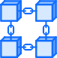

**Multi-chain platform**

Harness the best aspects of Ethereum, EOS and NEO



**Dapps**

Token creator, ICO campaign creator, Security token creator, DAO Company creator, Token Airdrop creator,



**Management tools**

Dashboard, Compliance and regulatory support



**Crypto Exchange**

Small to medium cap projects

### 5.1.1 Beneﬁts of a multi-chain platform

Blockchain technology provides a new way of creating, exchanging and tracking ﬁnancial assets. All transactions are on a peer-to-peer basis, cutting out the need for intermediaries or middlemen. The record of transactions is complete, transparent and tamper-proof. When smart contracts are added to automate predetermined contract terms, the system is even more robust and secure.

CryptoAssetBox plans to provide Dapps on 3 different blockchains - Ethereum, EOS and NEO. All of these blockchains support smart contracts. Currently, only Ethereum is being used. The other 2 blockchains are milestones in the roadmap.

The reason for having this multi-chain approach is two-fold. In the ﬁrst place it accommodates customers’ choice of blockchain. In the second place, each blockchain has its own individual features, all of which can be harnessed to provide the best solution for customers.

Having a Multichain platform means that:

* A wide range of cryptocurrencies can be created
* Applications will be scalable
* Tokens can be integrated

Part of the CryptoAssetBox solution is to provide interoperability across the Ethereum, EOS and NEO blockchains through Oraclize or Ducatur technologies.

### 5.1.2 Features of each chain

**Ethereum**



**The Ethereum blockchain is a platform for developers to build decentralized applications (Dapps). At its core is that it is a decentralized platform that runs smart contracts.**

Ethereum uses a proof-of-work consensus mechanism. It processes about 15 transactions per second (TPS). It is the most widely adopted platform with multiple resources for developers. Dapps and smart contracts must be written in Solidity. Users pay “gas” for each transaction.

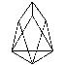

**EOS**

**EOS is designed as an operating system for Dapps. It has very high throughput, with the potential to process millions of transactions per second. Smart contracts can be written in C/C++. It has potential for high scalability and interoperability across blockchains.**

EOS uses the Delegated Proof of Stake (DPOS) protocol. Transactions are usually conﬁrmed within 1.5 seconds from the time of broadcast, by a 99.9% certainty. It operates on an ownership model, which means that owners of EOS tokens do not pay for use of the resources on the platform.



**NEO**

**NEO is designed to digitize assets, to self-manage them and to achieve a “smart economy”. It has multi-factor authentication methods to verify the identities of individuals, organisations and other entities.**

The smart contract can be used directly by almost any high-level programming language, which means that most developers will be able to participate without learning a new language. Existing business system code can be ported directly to the blockchain.

NEO uses the Delegated Byzantine Fault Tolerant (dBFT) consensus mechanism. Transaction throughput is very good at about 1,000 TPS, with potential to reach 10,000 TPS, allowing it to support large-scale commercial applications



## Business Dapps

CryptoAssetBox is a simple marketplace where businesses can access the following Dapps:

### 5.2.1 Token Creator

* Allows users to create their own ERC20 tokens with easy-to-use interface.

### 5.2.2 ICO Campaign Creator

* Allows users to create an entire ICO campaign as well as accept Ethereum-based funding from investors. A campaign investor just needs to send ether to the ICO contract address.

### 5.2.3 Security Token Creator

* Issues crypto tokens for regulated tradable securities
  + Shares or equity in traditional assets, startups, venture funds, real estate, etc
* Sport Team Fractional Ownership is the ﬁrst practical example that will be set up

### 5.2.4 Exchange Token Creator

* Allows for peer to peer exchange of tokens, without needing to work through an ofﬁcial exchange

### 5.2.5 DAO Company Creator*

* Create company, make proposals, vote on proposals, execute proposals, claim dividends
* Comprehensive governance framework
* Improved accuracy
* Transparency in voting
* Increased participation of shareholders

### 5.2.6 Token Airdrop Creator

* Users receive free tokens as part of a referral marketing campaign
* Encourage users to follow you on social media
* Achieve viral growth through the network effect

* DAO stands for Decentralized Autonomous Organization or a company that uses smart contracts. This means that its transactions are kept and retained on the blockchain.

## Management tools

### 5.3.1 Dashboard

* Manage tokens and crowdsale campaigns
* Deploy decentralized apps
* Have real-time view of fractional assets, offers and ﬁnancial activity
* View proposals and decisions for DAO

### 5.3.2 Compliance and regulatory support

* KYC, user Identity veriﬁcation, anti-fraud, E-signature and multi-regional tools based on various jurisdictions and legal requirements.
* CryptoAssetBox will develop partnerships with companies that provide KYC services to ensure that appropriate information is available, depending on geographic location of users.



## Crypto Exchange

* Immediately available for tokens issued on our platform
* Hi-tech security features
  + Tokens secured by air-gapped chilly stockpiling
  + 24/7 monitoring
* Specialized markers & vigorous API to educate and facilitate exchanges

The CryptoAssetBox solution:

Multi-chain platform – Ethereum, EOS and NEO

Pre-built decentralized applications (Dapps)

Management tools

Crypto exchange

Structure of CryptoAssetBox

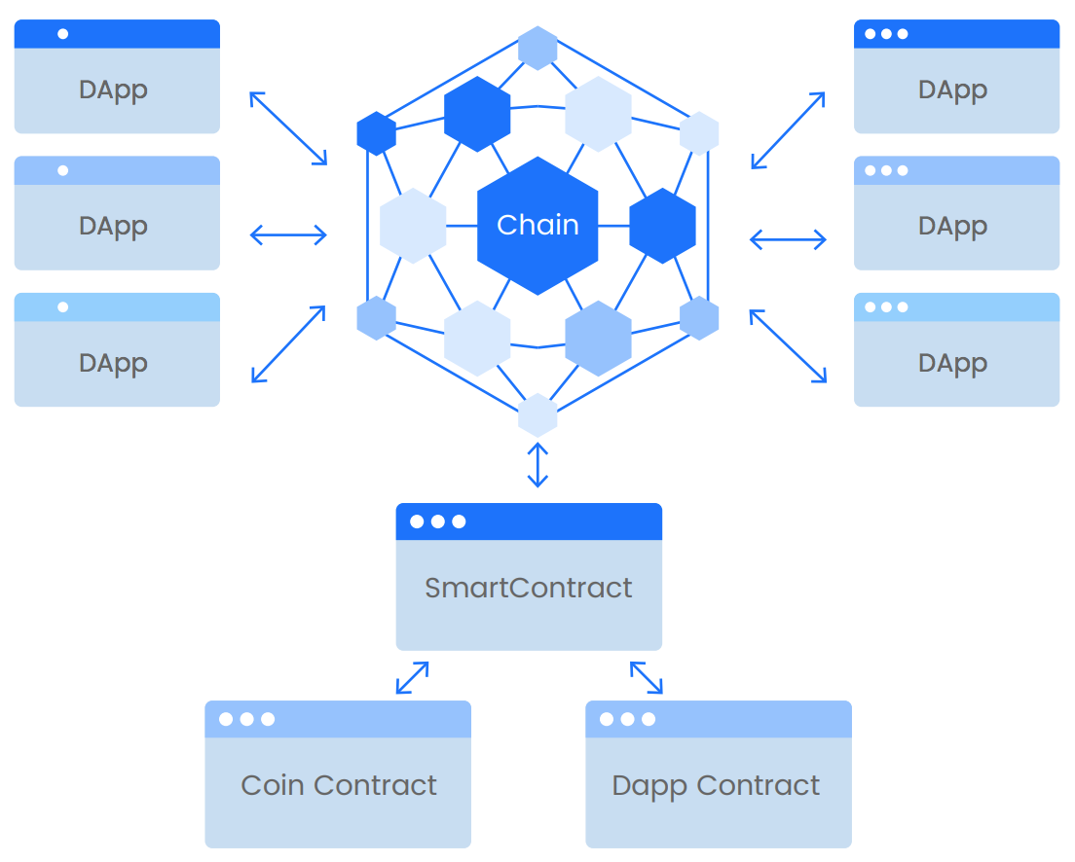

# The Risks

There are risks* associated with all businesses. These are some of the most important for *CryptoAssetBox.*

|  |  |
| --- | --- |
| Risk | *CryptoAssetBox* solution |
| Reputational risk due to misuse or hacking of user information | Routine maintenance and network management  Cybersecurity best practices  Blockchain itself and the use of private keys minimises risk, due to the limited amount of data stored and the encryption of that data |
| Risk that companies using the platform are involved in activities that are banned, restricted or deemed illegal in certain jurisdictions | CryptoAssetBox as the owner of the platform will provide governance for behaviour on the platform |
| Risk that companies using the platform are involved in activities that are banned, restricted or deemed illegal in certain jurisdictions | CryptoAssetBox as the owner of the platform will provide governance for behaviour on the platform |
| Future risk of new technologies that break blockchain security  Quantum computers and artiﬁcial intelligence may have the capacity to break any system, not just through sheer brute force, but also at great speed | Nearly every computer system in the world today is potentially at risk.  CryptoAssetBox technical team will remain abreast of all developing counter-measures being developed to counter this threat |

# The Market

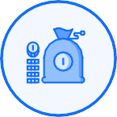

## The cryptocurrency market

**The market for cryptocurrencies is characterized by both growth and volatility.**

In July 2018, according to [Investing.com](https://www.investing.com/crypto/currencies), there were a total of 1907 currencies, but the market cap had fallen by a hundred billion dollars to $269 billion from the March ﬁgure of $369 billion. This was less than half of the market cap of about $800 billion in December 2017. The top 20 currencies (1% of the total) accounted for 88% of the value. The bottom 20% of the total (>350 currencies) had zero market value. Clearly, not all cryptocurrencies are worth paying attention to, and many will not survive.

It’s important to balance this picture by noting that the total market cap for crypto- currencies in July 2017 was just $95 billion. The current $269 billion represents a year-on-year growth of 183%. Many are predicting that it will reach a trillion dollars by the end of 2018, as signiﬁcantly more businesses are now revolving around cryptocurrencies and the skills around the technology are growing exponentially.

Lack of regulatory certainty is holding back growth. However, most countries are now working on this. This includes better regulation of the ICO market, to provide better transparency and to add more value to the cryptocurrency space.

However, to avoid risk it is important to carefully inspect projects before making a decision to contribute to them. The coins and tokens with the most utility value have least risk.

According to [Coinidol](https://coinidol.com/cryptocurrencies-that-will-not-survive-in-2018/), the best chance of success may be in “projects exteriorizing the real needs of cryptocurrency wallet owners, like convenient payment solutions, blockchain platforms and infrastructure, as well as investment and trading tools”.

The CryptoAssetBox business and the CABox token are both well-placed in this market. They provide real solutions to real business problems and open the market for current and potential holders of a wide variety of digital assets, not just cryptocurrencies.

The CAB Exchange will provide an investment and trading platform for holders of cryptocurrencies, including the CAB.

## The digital assets market

**Blockchain technology is poised to disrupt the traditional investment and ﬁnancial markets.**

It holds out the potential to exclude middlemen (and their costs), allowing for person-to-person transactions. It is safe and trustworthy as transactions are recorded on the blockchain in a way that can’t be altered. It provides transparency to replace the somewhat opaque way that traditional investments are managed.

Here are some comments from the traditional sector:

“Blockchain will bring a radical shift in the way we think about financial assets and the way the financial industry will operate in the future.”

JP Morgan

“Not so long ago, some experts argued that personal computers would never be adopted, and that tablets would only be used as expensive coffee trays, so I think it may not be wise to dismiss virtual currencies.”

Managing Director of the IMF, Christine Lagarde, 2017

High net worth individuals are becoming interested in cryptocurrencies. According to [The Capgemini World Wealth Report 2018](https://www.capgemini.com/news/capgeminis-world-wealth-report-2018-global-high-net-worth-individual-wealth-surpasses-us70-trillion-for-the-first-time/), 29% wanted to buy or hold cryptocurrencies, another 27% wanted to know more about them and about half were unhappy that their wealth managers were telling them too little.

Security tokens (or “fractional” tokens) are a natural bridge between the traditional ﬁnance sector and blockchain. Tokenized securities represent ownership in much the same way as stocks or share certiﬁcates do – they denominate real value of real assets, but managed in a new way. And they can be bought and sold in very small parts or fractions of the whole, with no limits to the size of investment needed.

The global stock market is said to be worth [$80 trillion](https://cryptovest.com/news/are-security-tokens-key-to-tapping-a-multi-trillion-dollar-industry/). Add to that assets that cannot be considered by Wall Street-type instruments and the total grows to about [$256 trillion](https://thenextweb.com/worldofbanking/2018/06/05/now-that-everything-can-be-tokenized-banks-are-taking-notice/). If only a very small fraction of this market moves into the digital world – such as that being supported by CryptoAssetBox – trillions of dollars will move to the crypto world.

# Competitor analysis

*CryptoAssetBox* is in an industry that might be new, but it is growing and it is very competitive.

A Google search for “companies that assist with ICOs” returned 419,000 results. [One site](http://startupmanagement.org/2017/09/22/the-whos-who-list-in-ico-service-providers/) provided 26 different services that are required, from ICO strategy and planning, through whitepaper writing, token economics, token issuance, order book building, press relations, marketing, KYC/AML processes, and others. It advised users that there were very few organizations providing a full suite of services, and that they should shop around to ﬁnd everything that they needed.

Similarly, a search for “companies that assist with security tokens” returned 15,2 million results.

Some of the companies that seem to be most similar to CryptoAssetBox, and where it might learn some valuable techniques, include Coinlaunch, Polymath and Blocktoken.

**Coinlaunch**

Coinlaunch provides Dapps that are very similar to those provided by CryptoAssetBox, for creating coins, setting up crowd sales and airdrop campaigns, providing securities and exchange tokens, undertaking KYC/AML/identity veriﬁcation and providing a management dashboard. It has some additional tools, including a Dapp Creator, APPChains, Website Widgets, events tickets and an Allocation Calculator. Coinlaunch claims to have raised $500m for clients already.

The focus of the company seems to have shifted to fractionalization, with its sub-company called Fraction/al. The aim is to tokenize corporate equity traditionally owned through exchanges or funds, sports and gaming teams, and ﬁnancial instruments like bonds, debts and commodities. There are active projects including the sale of tokens for real estate, a circuit and off-road racing team and a tourist village in Portugal.

CryptoAssetBox has a slightly different focus, although it supplies similar products. By adding the DAO Creator and the Crypto Exchange it has provided more end-to-end business services for its clients. And by having a multichain platform, it extends its reach for clients as well as providing more technological solutions.

**Polymath**

The focus of Polymath is the launching of securities tokens. It advertises that it enables the creation, issuance and trading of ﬁnancial instruments on the blockchain.

Much of its attention is going into ensuring compliance and meeting regulations. It is meeting with government and legal ofﬁcials in various countries to ensure that localized regulations are embedded into all tokens before they are released. Even its own token, the POLY, can only be bought and sold by veriﬁed buyers.

Polymath believes that strict regulation is coming for all ICOs and all tokens, and that it would be better to be ahead of the regulators. It hopes to establish a new standard for security coins – the ST-20.

CryptoAssetBox will also be issuing security tokens and will be monitoring what Polymath does to ensure compliance, especially with the ST-20 standard that it may be able to incorporate into its own product.

**Blocktoken.**

Blocktoken launches and markets ICOs. It provides services for the issuance of tokens, but its focus is more on bringing in the funds from these ICOs. This is through marketing campaigns to build the audience for the ICO and on investor roadshows, ﬁnding and meeting with potential investors, including crypto analysts and fund managers.

Although ICO campaigns is only one of the services offered by CryptoAssetBox, it would do well to monitor the techniques used by companies such as Blocktoken, to strengthen its own marketing approaches.

**CryptoAssetBox competitive advantage.**

Blockchain technology is changing the way that business is being done in the world. CryptoAssetBox is one of the companies that is capitalising on this change, by providing some of the new services required and by implementing emerging technologies. It has packaged its services into a “box” of business support tools that will make business easier for its customers and will at the same time keep them coming back for more.

The CryptoAssetBox competitive advantage:

A wide range of business support services in one “box”

Combining technologies to provide the best solutions for clients

# Business plan

What are the income streams for *CryptoAssetBox* and how scalable is the business?

Of importance to note here is that there is already a working product, with users trying and reviewing the Dapps. New Dapps will be developed and added to the platform over time. Other businesses can also be built on the same platform. The ﬁrst will be a crypto exchange.

## Income streams and projected earnings from Dapps

The main forms of income are fees and commissions from Dapps. Users may pay a fee to launch a token – for example 1.5 ETH when they deploy a security token. They will pay commissions when they use some of the on-platform Dapps, like the ICO Campaign creator. The following table gives an indication of the pricing structure, current development status, revenue streams and potential for income of the current Dapps, per 100 users.

|  |  |  |  |  |  |
| --- | --- | --- | --- | --- | --- |
| **REVENUE STREAMS & POTENTIAL - PER 100 USERS** | | | | | |
| **ICO Campaign Creator** | **Security Token Creator** | **DAO**  **Company Creator** | **Fractional Token Creator** | **Token Airdrop Creator** | **Exchange Token Creator** |
| Set up ICO & collect funds | Tokens for real world assets | Governance Framework | Share in sports team | Digital referral marketing | P2P exchange of tokens |
| **MVP Stage** | **MVP Stage** | **Coming soon** | **Coming soon** | **MVP Stage** | **MVP Stage** |
| **Essential**  2 ETH + 5%  commission on ICO  **15% of users**  **Enterprise**  4 ETH + 3.9%  commission on ICO  **5% of users**  **Premium**  10 ETH + 0%  commission on ICO  **5% of users**  **$1,8M** | 1.5 ETH  35% of users  **$26,3M** | 30 ETH  10% of users  **$150M**  **POTENTIAL**  **$2M**  **PER 100 USERS**  **Assuming 1 ETH = $500** | 20 ETH  7.5% of users  **$75K** | 1.3 ETH  15% of users  **$9,8k** | 2.5 ETH  7.5% of users  **$9,4k** |

To be noted from this table:

* Four of the Dapps are already at MVP stage, with two coming soon
* Five of the Dapps charge fees only for the use of the Dapp. For example, the Security Token Creator charges 1.5 ETH, and the DAO Company Creator charges 30 ETH
* The ICO Campaign Creator charges fees for the use of the Dapp and also commission on the funds raised by the ICO. There are 3 different packages available for this.
* In this table some assumptions have been made. For example,
  + - We have assumed that 35% of users will use the Security Token Creator and 10% will use the DAO Company Creator.
    - We have also assumed that users who choose the Essential package for ICO Creator will raise approx $1m, Enterprise approx $5m and Premium $10m in their ICOs. (CryptoAssetBox will do in-depth due diligence on all projects wanting to undertake ICOs to ensure that they have a good chance of success.)
* We have used these assumptions to project possible earnings per 100 users.
* It is noted that the number of unique users will be lower than 100. For example, it is likely that many users who use the ICO Campaign Creator will also use the DAO Dapp and the Airdrop Dapp.
* There will be a cross beneﬁt for the proposed CAB Exchange, with most of the users listing their own tokens on this exchange.

Projected revenues per hundred users

|  |  |  |  |  |  |  |  |
| --- | --- | --- | --- | --- | --- | --- | --- |
|  | ICO  Campaign Creator | Security Token Creator | DAO  Company Creator | Fractional Token Creator | Token Airdrop Creator | Exchange Token Creator | Total per 100 users |
| Assumed no of users | 25 | 35 | 10 | 7,5 | 15 | 7,5 | 100 |
| Fees in $ @  $500 per ETH | $50,000 | $26,250 | $150,000 | $75,000 | $9,750 | $9,375 | $270,375 |
| Commissions in $ | $1,725,000 |  |  |  |  |  | $1,725,000 |
| Total projected income per Dapp, per 100 users | **$1,775,000** | **$26,250** | **$150,000** | **$75,000** | **$9,750** | **$9,375** | **$2,045,375** |

This projection suggests that approx $2m could be earned from 100 users.

During the ﬁrst year, the plan is to target 25 potential users of the ICO Campaign Creator and 10 for the Security and/or Fractional Token Creators. The assumption is that 90% of them will register on the exchange and 10% will also use the DAO Creator.

Due diligence to all applications will ensure that ICO that are launched will be successful, reaching a cap of at least $1 million. We have made projections based on only 25 ICOs per year, but believe that this will grow every year, and that the amounts raised will grow signiﬁcantly.

Considerable attention will be given to the marketing of Security and Fractional Tokens with fast growth expected from Year 2. Approaches will be made to existing real asset investments, where the usage of a Dapp will relieve them of administrative burdens and provide them with improved security on their transactions.

Based on these plans, the following graphs provide a very conservative picture of the potential for growth and revenue.

Projected growth in users over 3 years

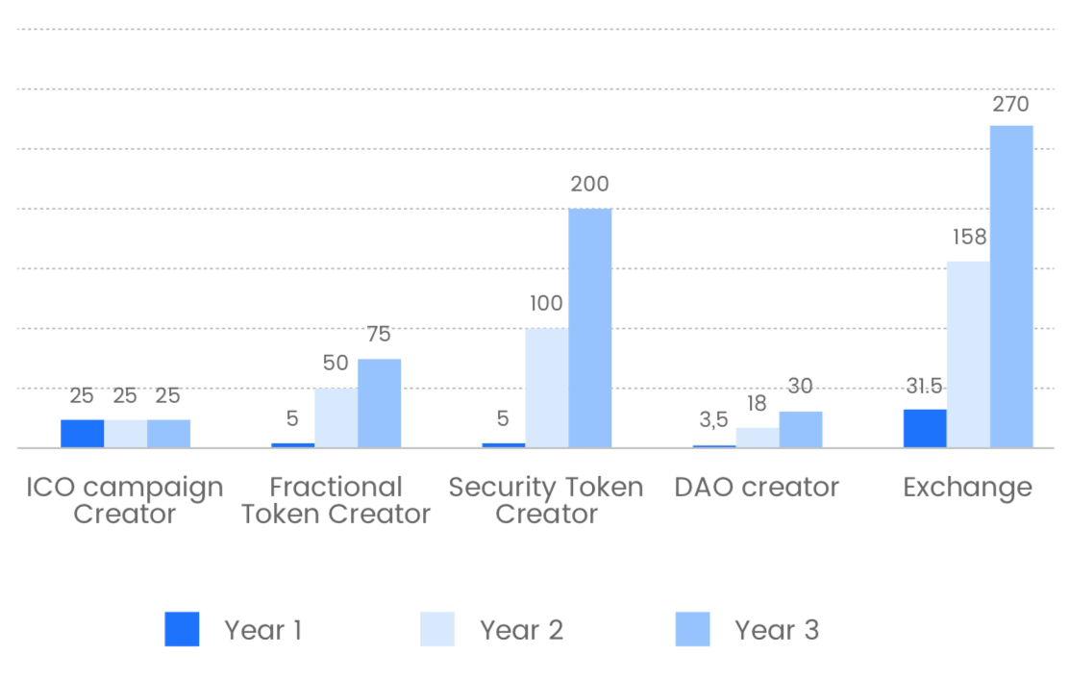

Number of users on Exchange based on 90% of users of other Dapps also using exchange. This excludes users from other sources.

Projected revenue from 4 Dapps over 3 years

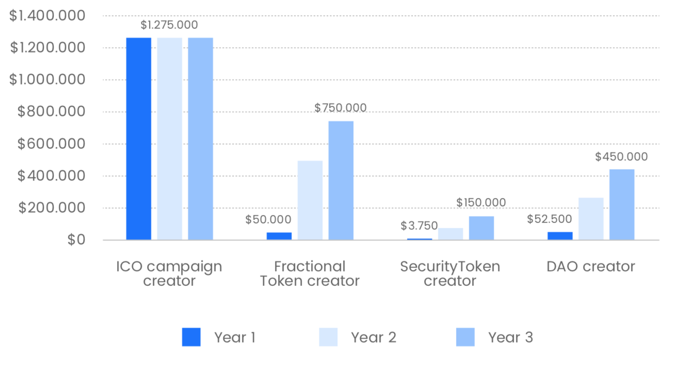

This represents a growth in revenue from $1.4m in Year 1 to $2,6m in Year 3.

Further growth will come from adding new Dapps and increased marketing (including word-of-mouth marketing which we are anticipating from current users). This projection was also done based on only $1m being raised per ICO – this is likely to rise.

## Income streams and projected earnings from Crypto Exchange

Other businesses can be launched off the CryptoAssetBox platform. One of the ﬁrst will be the CABEX crypto exchange. The exchange is already at MVP stage.

Income from the Exchange will be from listing fees (between 3 and 6 BTC depending on the complexity of setup) and commissions on transactions at 0.2%, which is the average for most exchanges.

The following projections are based on 90% of users of Dapps listing on the Exchange (we have used only 3BTC as the listing fee) and starting with a very small daily trade of only $50 BTC. This is about half of a small exchange like Alpha BTC.

Projected daily trade in BTC

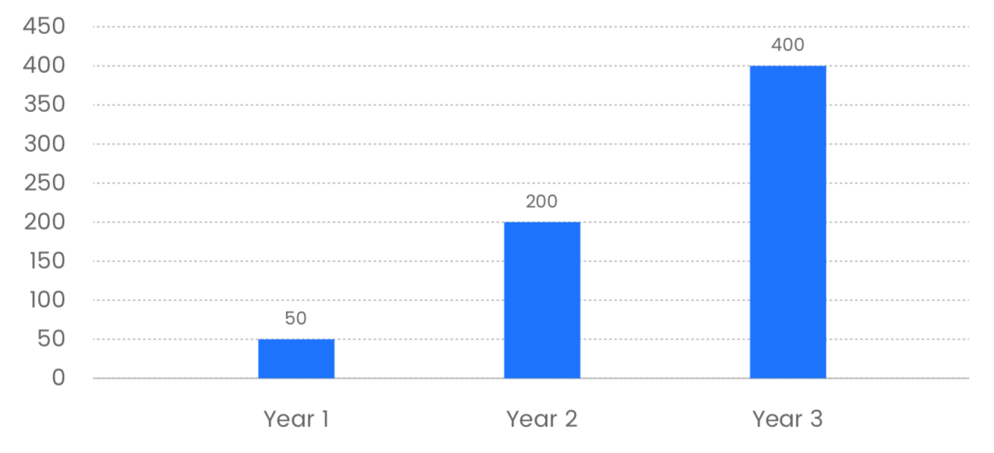

Projected revenue from Exchange over 3 years

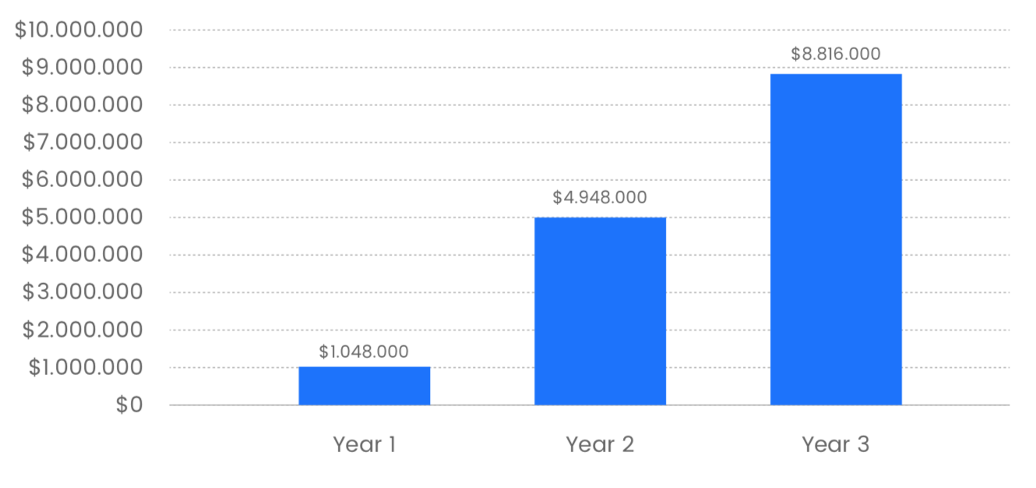

This projection represents a revenue of approx $15 million over 3 years. If the exchange grows to anything like the size of other exchanges in the market, this ﬁgure could reach hundreds of millions. This is particularly true if the expected boom in security tokens happens. According to Bloomberg, the top 10 digital-assets exchanges are generating up to $3 million per day.

The combined revenue from Dapps and the Exchange over the next few years is shown below:

Total projected revenue over 3 years

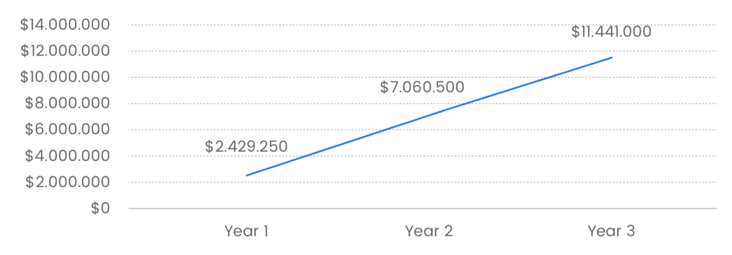

This represents over $20 million in revenue over 3 years.

# Roadmap

**Q3 2018**

*Finalization of whitepaper, website and marketing material*

**Q3 2017:**

CryptoAssetBox idea

MVP release for ETH, the ﬁrst use-case for

CryptoAssetBox

**Q4 2017:**

CryptoAssetBox platform extension Enhancement of issuance of security tokens

Enhancement of crowdsale campaign workﬂow

**Q1 2018:**

CryptoAssetBox security system Design of multichain mechanism

Legal analytics design

**Q2 2018:**

Consolidation of financial model

**Q4 2018:**

Launch of CAB Exchange

Enhancement of Fractional Ownership

Enhancement of DAO creator

Integration of EOS for Dapps

Release of multichain (ETH, EOS, NEO)

**Q1 2019:**

Mobile Dapps for crypto assets

Launch of mobile version of

CryptoAssetBox on Google Play and Apple Store

**Q2 2019:**

Enhancement of user experience

**Q3 2019:**

Release of eCommerce-based crypto

assets

Integration of proof of stake model

**Q4 2019:**

Interoperability between blockchains

Issue of debit card for decentralized ecosystem

# Reasons to invest in CryptoAssetBox

All start-ups present some degree of risk, and investing in token sales can be particularly risky. However, there are some good reasons to invest in CryptoAssetBox.

* **There is already a working project**
* CAB token is backed by working project at MVP stage
* All the tools in one box means perennial sales
* **Regulation mitigates risk for investors**
  + CryptoAssetBox will be a regulated marketplace for the issuance of crypto assets
  + All legal and regulatory requirements will be imbedded into tokens representing crypto assets, and will be governed by smart contracts
  + Strict KYC protocols will be followed
* **Share in the proﬁts**
* 60% of CryptoAssetBox's quarterly proﬁts will be distributed to CAB token holders once a quarter.
* Share in every listing on the exchange and share commission on trades
* Receive a fee for referring clients for ICO services
* Beneﬁt from the growth in value of CAB tokens

The ﬁrst multichain-based marketplace for the issuance of crypto assets for business